**Qlik Analysis of Road Safety and Accident Patterns in India**

The project leverages Qlik's data analytics platform to analyze road safety and accident patterns in India. By utilizing various data sources such as traffic data, accident reports, weather conditions, road infrastructure details, and demographic information, the project aims to identify trends, hotspots, and contributing factors to road accidents. This analysis will aid stakeholders, including government authorities, transportation agencies, and road safety organizations, in making data-driven decisions to enhance road safety measures, reduce accidents, and save lives.

**Scenario 1: Hotspot Identification** Qlik's analytics can pinpoint regions or specific roads in India with a high frequency of accidents. By correlating accident data with factors such as traffic volume, road conditions, and time of day, the platform can identify accident-prone hotspots. This information is crucial for implementing targeted interventions, such as enhanced traffic monitoring, improved signage, and adjusted speed limits.

**Scenario 2: Trend Analysis** Qlik can perform trend analysis on historical accident data to identify patterns and recurring factors leading to accidents. This includes analyzing accident types (e.g., collisions, pedestrian accidents), seasonal variations, and driver behaviors (e.g., speeding, distracted driving). Insights gained from this analysis can guide awareness campaigns, driver training programs, and policy reforms aimed at addressing the root causes of accidents.

**Scenario 3: Predictive Modeling** Using predictive analytics, Qlik can forecast potential accident scenarios based on real-time data inputs. By considering variables such as weather forecasts, traffic flow patterns, and historical accident trends, the platform can provide early warnings and proactive measures to prevent accidents. This predictive capability empowers authorities to deploy resources strategically and implement preemptive safety measures.

### Project Flow

1. Define Problem / Problem Understanding

* Specify the business problem
* Business requirements
* Literature Survey
* Social or Business Impact

2. Data Collection

* Collect the dataset
* Connect Data with Qlik Sense

3. Data Preparation

* Prepare the Data for Visualization

4. Data Visualizations

* Number of Unique Visualizations

5. Dashboard

* Responsive and Design of Dashboard

6. Story

* Story Creation

7. Performance Testing

* Amount of Data Rendered to DB
* Utilization of Data Filters
* Number of Calculation Fields/Master Items
* Number of Visualizations/Graphs

8. Project Demonstration & Documentation

* Record explanation Video for project end-to-end solution
* Project Documentation - Step by step project development procedure

**Define Problem / Problem Understanding**

### Specify The Business Problem

Technological advancement in transportation has minimised the distances but has increased the risk to life. Every year, accidents result in loss of lakhs of lives and serious injuries to crores of people. A study to analyse road safety and accident trends in India is to be conducted using Qlik Sense, a data analytics platform. This study involves examining data related to road incidents, such as types of accidents, locations, causes, and potentially factors contributing to road safety or risks. The use of Qlik Sense is a data-driven approach, utilizing visualizations and insights generated from the analysis to understand patterns and potentially inform strategies for improving road safety in India.

### Business Requirements

The analysis aims to provide valuable insights into user demographics, accident patterns, and problem areas. The primary focus is on creating interactive and visually compelling dashboards to support strategic planning and operational improvements. The insights derived from this analysis will be instrumental in making informed decisions, implementing better safety protocols, and ensuring compliance with regulations.

### Literature Survey

A literature survey for the Road Safety and Accident Patterns analysis would involve researching and reviewing previous studies, articles, reports and figures on the topic. This could include information on the methods and techniques used for analysing accidents data, as well as the results and conclusions of these studies. It is recommended to explore academic databases such as PubMed, IEEE Xplore, Google Scholar, and institutional repositories. Additionally, government reports and publications can provide insights into the latest developments.

### Social Impact

Social Impact Analysis:

• Create visualizations to display the demographic distribution of accidents across the country.

• Compare the severity of accidents in different areas of traffic control.

• Explore any correlation between speeding, weather, and total accidents.

• Identify the leading causes of accidents.

• Examine the distribution of age groups and gender of the victims.

• Investigate the contribution of diverse types of vehicles to the total number of accidents.

### Data Collection & Extraction From Database

Data collection is the process of gathering and measuring information on variables of interest,

in an established systematic fashion that enables one to answer stated research questions, test hypotheses, evaluate outcomes and generate insights from the data.

### Downloading The Dataset

### ROAD ACCIDENTS IN INDIA

### Kaggle is the world’s largest data science community with powerful tools and resources to help you achieve.

### <https://www.kaggle.com/datasets/aryakittukrishnasai/road-accidents-in-india>

## About Dataset

State/UT-wise Pedestrians killed according to classification of age and sex during 2019  
State/UT-wise Pedestrians killed in Accidents Classified by the type of impacting vehicles during 2019  
State/UT-wise Accidents Classified according to Type of Traffic Control during 2019  
State/UT-wise Accidents classified according to Load Condition of Involved Vehicle during 2019  
State/UT-wise Two Wheelers killed in Accidents Classified by the type of impacting vehicles during 2019  
State/UT-wise Male and Female Persons Killed in Road Accidents in terms of Road User categories during 2019  
State/UT-wise Accidents Victims Classified according to Non-Use of Safety Device (Non Wearing of Helmet) during 2019 etc

**Understand The Data**

Data contains all the meta information regarding the columns described in the Excel files.

Description of the Dataset:

There are nine data files that have been converted to Excel worksheets(.xlsx) for ease of use with respect to Qlik Sense. The list of files is as follows:

1. Pedestrians: State/UT-wise pedestrians involved in accidents according to classification of age and gender during 2019.

Columns of the dataset:

1. State/UT
2. Less than 18 years – Male
3. Less than 18 years – Female
4. 18-25 Years – Male
5. 18-25 Years – Female
6. 25-35 Years – Male
7. 25-35 Years – Female
8. 35-45 Years – Male
9. 35-45 Years – Female
10. 45-60 Years – Male
11. 45-60 Years – Female
12. 60 and Above – Male
13. 60 and Above – Female
14. Age not known – Male
15. Age not known – Female

1. Pedestrians killed: State/UT-wise pedestrians killed according to classification of age and gender during 2019.

Columns of the dataset:

1. State/UT
2. Less than 18 years - Killed - Male
3. Less than 18 years - Killed - Female
4. 18-25 Years - Killed - Male
5. 18-25 Years - Killed - Female
6. 25-35 Years - Killed - Male
7. 25-35 Years - Killed - Female
8. 35-45 Years - Killed - Male
9. 35-45 Years - Killed - Female
10. 45-60 Years - Killed - Male
11. 45-60 Years - Killed - Female
12. 60 and Above - Killed - Male
13. 60 and Above - Killed - Female
14. Age not known - Killed – Male
15. Age not known - Killed – Female

1. Pedestrians killed – Impacting vehicles: State/UT-wise Pedestrians killed in accidents classified by the type of impacting vehicles during 2019

Columns of the dataset:

1. States/UTs
2. Bicycles
3. Two Wheelers
4. Auto Rickshaws
5. Cars, Taxis, Vans and LMV
6. Trucks/Lorries
7. Buses
8. Other Non-Motorized Vehicles (E-rickshaw etc.)
9. Others
10. Total

1. Traffic Control Type: State/UT-wise accidents classified according to the type of traffic control during 2019

Columns of the dataset:

1. States/UTs
2. Traffic Light Signal - Total number of Accidents
3. Traffic Light Signal - Persons Killed
4. Traffic Light Signal - Persons Injured - Grievously Injured
5. Traffic Light Signal - Persons Injured - Minor Injury
6. Traffic Light Signal - Persons Injured - Total Injured
7. Police Controlled - Total number of Accidents
8. Police Controlled - Persons Killed
9. Police Controlled - Persons Injured - Grievously Injured
10. Police Controlled - Persons Injured - Minor Injury
11. Police Controlled - Persons Injured - Total Injury
12. Stop Sign - Total number of Accidents
13. Stop Sign - Persons Killed
14. Stop Sign - Persons Injured - Grievously Injured
15. Stop Sign - Persons Injured - Minor Injury
16. Stop Sign - Persons Injured - Total Injured
17. Flashing Signal/Blinker - Total number of Accidents
18. Flashing Signal/Blinker - Persons Killed
19. Flashing Signal/Blinker - Persons Injured - Grievously Injured
20. Flashing Signal/Blinker - Persons Injured - Minor Injury
21. Flashing Signal/Blinker - Persons Injured - Total Injured
22. Uncontrolled - Total number of Accidents – Number
23. Uncontrolled - Total number of Accidents – Rank
24. Uncontrolled - Persons Killed – Number
25. Uncontrolled - Persons Killed – Rank
26. Uncontrolled - Persons Injured - Grievously Injured
27. Uncontrolled - Persons Injured - Minor Injury
28. Uncontrolled - Persons Injured - Total Injured
29. Others - Total number of Accidents
30. Others - Persons Killed
31. Others - Persons Injured - Grievously Injured
32. Others - Persons Injured - Minor Injury
33. Others - Persons Injured - Total Injured

1. Weather: State/UT-wise accidents classified according to the type of weather and severity of the accidents during 2019

Columns of the dataset:

1. States/UTs
2. Sunny/Clear - Total Accidents – Number
3. Sunny/Clear - Total Accidents – Rank
4. Sunny/Clear - Persons Killed – Number
5. Sunny/Clear - Persons Killed – Rank
6. Sunny/Clear - Persons Injured - Grievously Injured
7. Sunny/Clear - Persons Injured - Minor Injury
8. Sunny/Clear - Persons Injured - Total Injured
9. Rainy - Total Accidents
10. Rainy - Persons Killed
11. Rainy - Persons Injured - Grievously Injured
12. Rainy - Persons Injured - Minor Injury
13. Rainy - Persons Injured - Total Injured
14. Foggy and Misty - Total Accidents
15. Foggy and Misty - Persons Killed
16. Foggy and Misty - Persons Injured - Grievously Injured
17. Foggy and Misty - Persons Injured - Minor Injury
18. Foggy and Misty - Persons Injured - Total Injured
19. Hail/Sleet - Total Accidents
20. Hail/Sleet - Persons Killed
21. Hail/Sleet - Persons Injured - Grievously Injured
22. Hail/Sleet - Persons Injured - Minor Injury
23. Hail/Sleet - Persons Injured - Total Injured
24. Others - Total Accidents
25. Others - Persons Killed
26. Others - Persons Injured - Grievously Injured
27. Others - Persons Injured - Minor Injury
28. Others - Persons Injured - Total Injured

1. Killed on Two Wheelers - Impacting vehicles: State/UT-wise Two Wheelers killed in accidents classified by the type of impacting vehicles during 2019

Columns of the dataset:

1. States/UTs
2. Bicycles
3. Two Wheelers
4. Auto Rickshaws
5. Cars, Taxis, Vans and LMV
6. Trucks/Lorries
7. Buses
8. Other Non-Motorized Vehicles (E-rickshaw etc.)
9. Others
10. Total

1. Road Users Killed – Gender: State/UT-wise male and female persons killed in road accidents in terms of road user categories during 2019

Columns of the dataset:

1. States/UTs
2. Pedestrian – Male
3. Pedestrian – Female
4. Pedestrian – Total
5. Bicycles – Male
6. Bicycles – Female
7. Bicycles – Total
8. Two Wheelers – Male
9. Two Wheelers – Female
10. Two Wheelers – Total
11. Two Wheelers – Rank
12. Auto Rickshaws – Male
13. Auto Rickshaws – Female
14. Auto Rickshaws – Total
15. Cars, taxies Vans and LMV – Male
16. Cars, taxies Vans and LMV – Female
17. Cars, taxies Vans and LMV – Total
18. Trucks/Lorries – Male
19. Trucks/Lorries – Female
20. Trucks/Lorries – Total
21. Buses – Male
22. Buses – Female
23. Buses – Total
24. Other non-Motor vehicles(E-Rickshaw) – Male
25. Other non-Motor vehicles(E-Rickshaw) – Female
26. Other non-Motor vehicles(E-Rickshaw) – Total
27. Others – Male
28. Others – Female
29. Others - Total

1. Causes: State/UT-wise Accident victims classified according to the causes of accidents during 2019

Columns of the dataset:

1. States/UTs
2. Over-Speeding - Number of Accidents – Number
3. Over-Speeding - Number of Accidents – Rank
4. Over-Speeding - Persons Killed – Number
5. Over-Speeding - Persons Killed – Rank
6. Over-Speeding - Persons Injured - Grievously Injured
7. Over-Speeding - Persons Injured - Minor Injury
8. Over-Speeding - Persons Injured - Total Injured
9. Drunken Driving/ Consumption of alcohol and drug - Number of Accidents
10. Drunken Driving/ Consumption of alcohol and drug - Persons Killed
11. Drunken Driving/ Consumption of alcohol and drug - Persons Injured - Grievously Injured
12. Drunken Driving/ Consumption of alcohol and drug - Persons Injured - Minor Injury
13. Drunken Driving/ Consumption of alcohol and drug - Persons Injured - Total Injured
14. Driving on Wrong side - Number of Accidents
15. Driving on Wrong side - Persons Killed
16. Driving on Wrong side - Persons Injured - Grievously Injured
17. Driving on Wrong side - Persons Injured - Minor Injury
18. Driving on Wrong side - Persons Injured - Total Injured
19. Jumping Red Light - Number of Accidents
20. Jumping Red Light - Persons Killed
21. Jumping Red Light - Persons Injured - Grievously Injured
22. Jumping Red Light - Persons Injured - Minor Injury
23. Jumping Red Light - Persons Injured - Total Injured
24. Use of Mobile Phone - Number of Accidents
25. Use of Mobile Phone - Persons Killed
26. Use of Mobile Phone - Persons Injured - Grievously Injured
27. Use of Mobile Phone - Persons Injured - Minor Injury
28. Use of Mobile Phone - Persons Injured - Total Injured
29. Others - Number of Accidents
30. Others - Persons Killed
31. Others - Persons Injured - Grievously Injured
32. Others - Persons Injured - Minor Injury
33. Others - Persons Injured - Total Injured

1. Accidents – Severity and Vehicles: State/UT-wise vehicle type of victims and severity of accidents during 2019

Columns of the dataset:

1. States/UTs
2. Pedestrian - Number of Road Accidents
3. Pedestrian - Number of Persons – Killed
4. Pedestrian - Number of Persons - Grievously Injured
5. Pedestrian - Number of Persons - Minor Injured
6. Bicycles - Number of Road Accidents
7. Bicycles - Number of Persons – Killed
8. Bicycles - Number of Persons - Grievously Injured
9. Bicycles - Number of Persons - Minor Injured
10. Two Wheelers - Number of Road Accidents
11. Two Wheelers - Number of Persons – Killed
12. Two Wheelers - Number of Persons - Grievously Injured
13. Two Wheelers - Number of Persons - Minor Injured
14. Auto Rickshaws - Number of Road Accidents
15. Auto Rickshaws - Number of Persons – Killed
16. Auto Rickshaws - Number of Persons - Grievously Injured
17. Auto Rickshaws - Number of Persons - Minor Injured
18. Cars, Taxis, Vans and LMV - Number of Road Accidents
19. Cars, Taxis, Vans and LMV - Number of Persons – Killed
20. Cars, Taxis, Vans and LMV - Number of Persons - Grievously Injured
21. Cars, Taxis, Vans and LMV - Number of Persons - Minor Injured
22. Trucks/Lorries - Number of Road Accidents
23. Trucks/Lorries - Number of Persons – Killed
24. Trucks/Lorries - Number of Persons - Grievously Injured
25. Trucks/Lorries - Number of Persons - Minor Injured
26. Buses - Number of Road Accidents
27. Buses - Number of Persons – Killed
28. Buses - Number of Persons - Grievously Injured
29. Buses - Number of Persons - Minor Injured
30. Other non-motorized vehicle (E-rickshaw etc.) - Number of Road Accidents
31. Other non-motorized vehicle (E-rickshaw etc.) - Number of Persons – Killed
32. Other non-motorized vehicle (E-rickshaw etc.) - Number of Persons - Grievously Injured
33. Other non-motorized vehicle (E-rickshaw etc.) - Number of Persons - Minor Injured
34. Others - Number of Road Accidents
35. Others - Number of Persons – Killed
36. Others - Number of Persons - Grievously Injured
37. Others - Number of Persons - Minor Injured
38. Total - Number of Road Accidents
39. Total - Number of Persons – Killed
40. Total - Number of Persons - Grievously Injured
41. Total - Number of Persons - Minor Injured

### Data Preparation

**Prepare The Data For Visualization**

Preparing the data for visualization involves cleaning the data to remove irrelevant or  
missing data, transforming the data into a format that can be easily visualized, exploring the data to identify patterns and trends, filtering the data to focus on specific subsets of data, preparing the data for visualization software, and ensuring that the data is accurate and complete. This process helps to make data easily understandable and ready for creating visualizations to gain insights.

### Data Visualization

Data visualization is the process of creating graphical representations of data to help people understand information. The goal of data visualization is to make complex data sets more accessible, intuitive, and easier to interpret. By using visual elements such as charts, graphs, and maps, data visualization can help people identify patterns, trends, and outliers quickly in the data.

### Number Of Unique Visualizations

The number of unique visualizations that can be created with a given dataset. Some common types of visualizations that can be used to analyse include bar charts, line charts, heat maps, scatter plots, pie charts, maps etc. These visualizations can be used to compare, track changes over time, show distribution, relationships between variables, breakdown of one category and much more.

Activity 1.1: Accidents due to Drunken Driving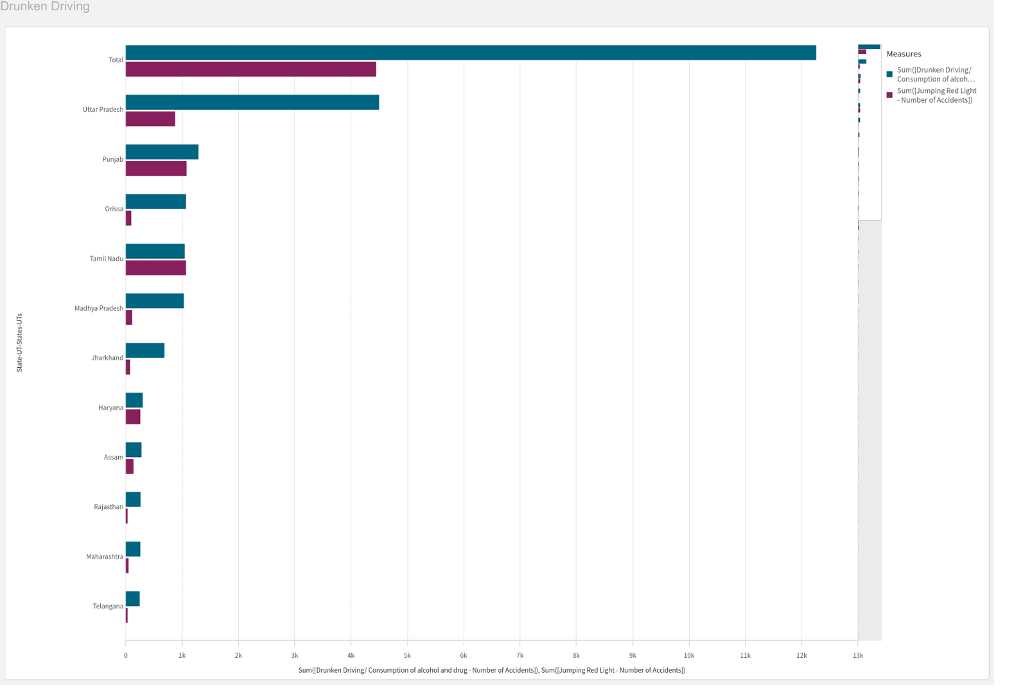

Activity 1.2: State-wise Mobile Phone Usage

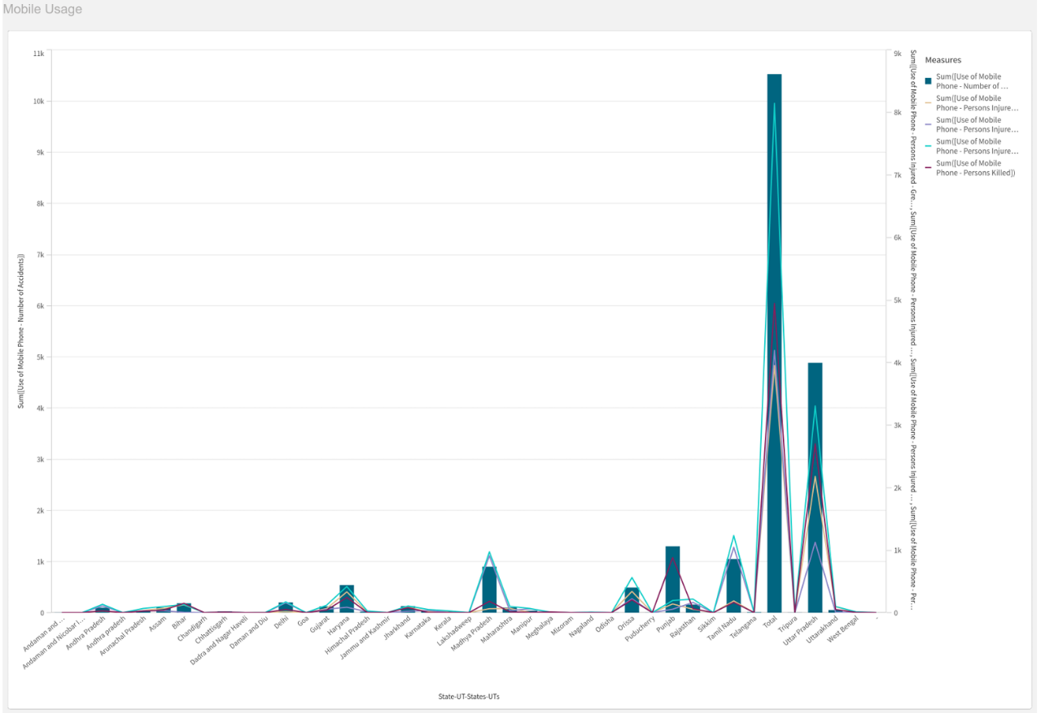

\

Activity 1.3: Pedestrians Killed: Age groups

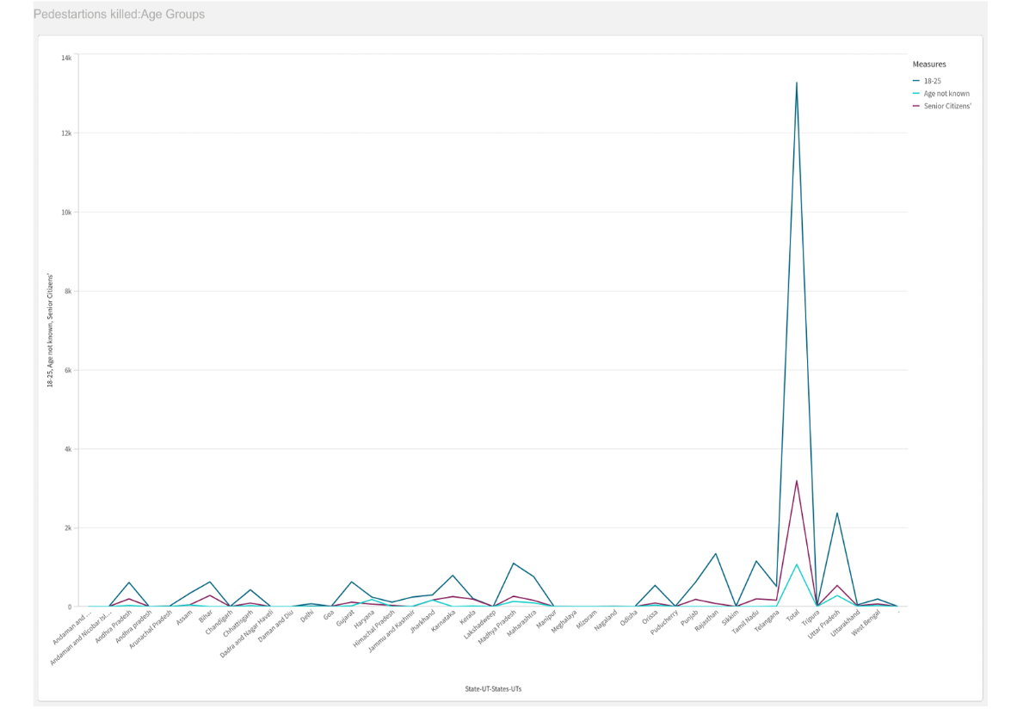

Activity 1.4: Vehicle Contribution towards Total Accidents

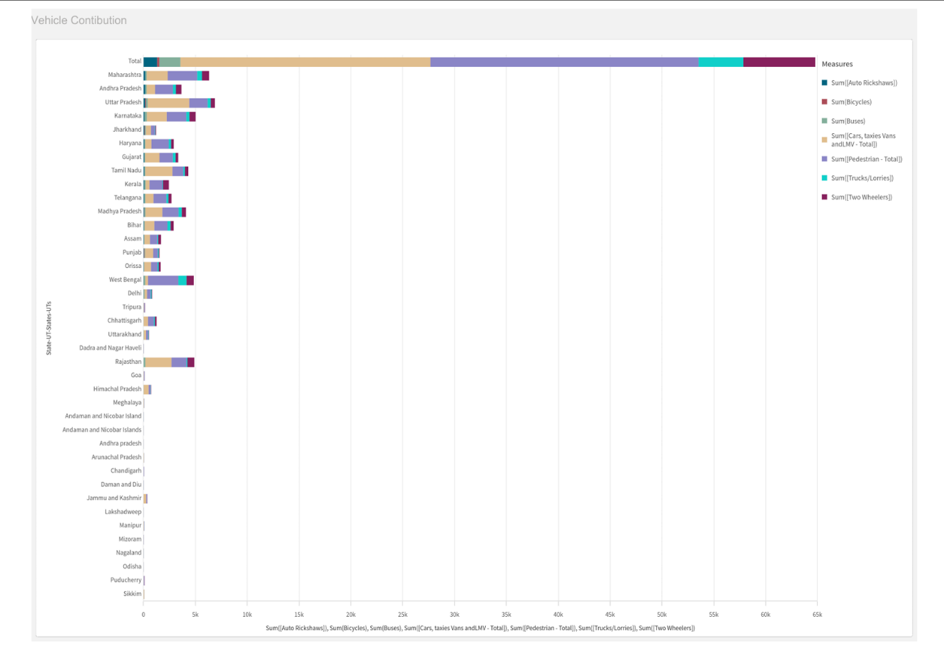

Activity 1.5: Accidents by Weather Type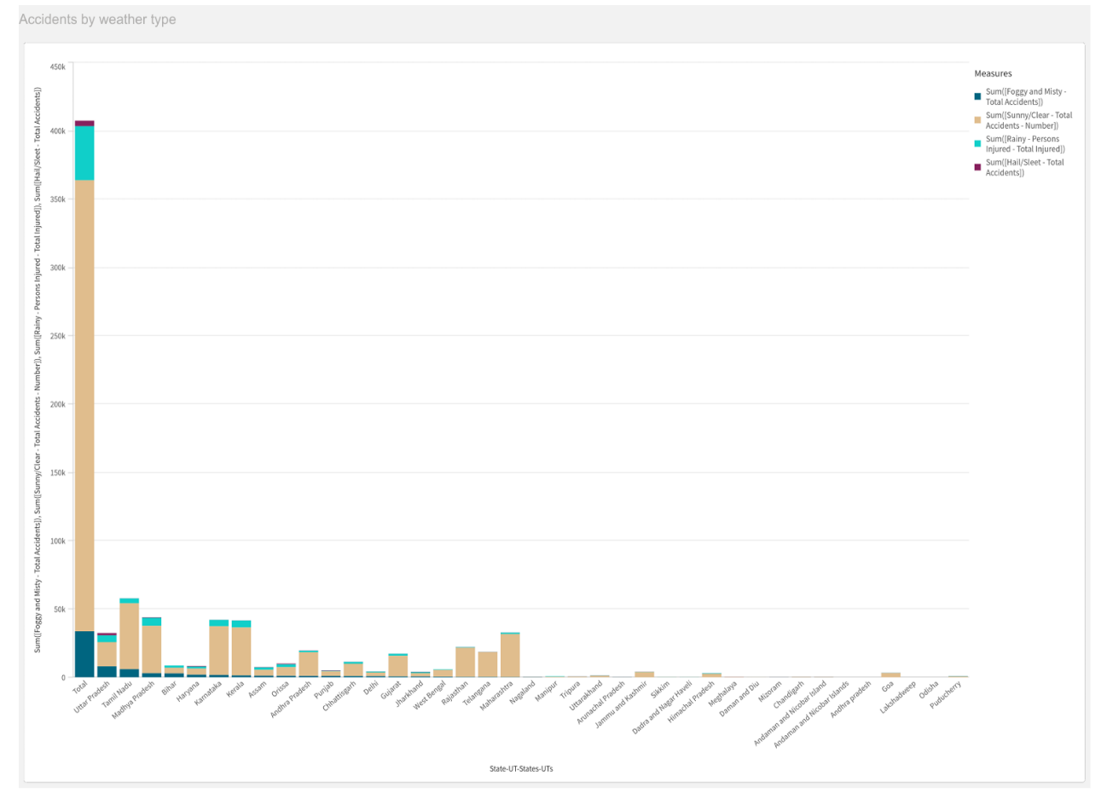

Activity 1.6: Pedestrians Killed: Gender

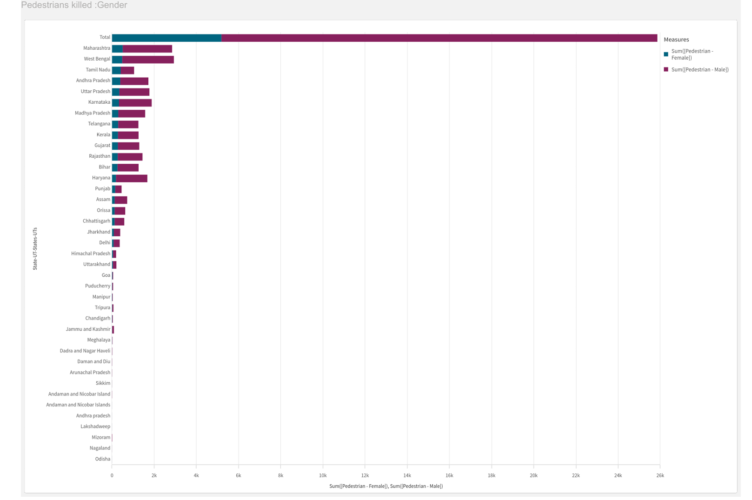

Activity 1.7: Road Users Killed: Vehicle Distribution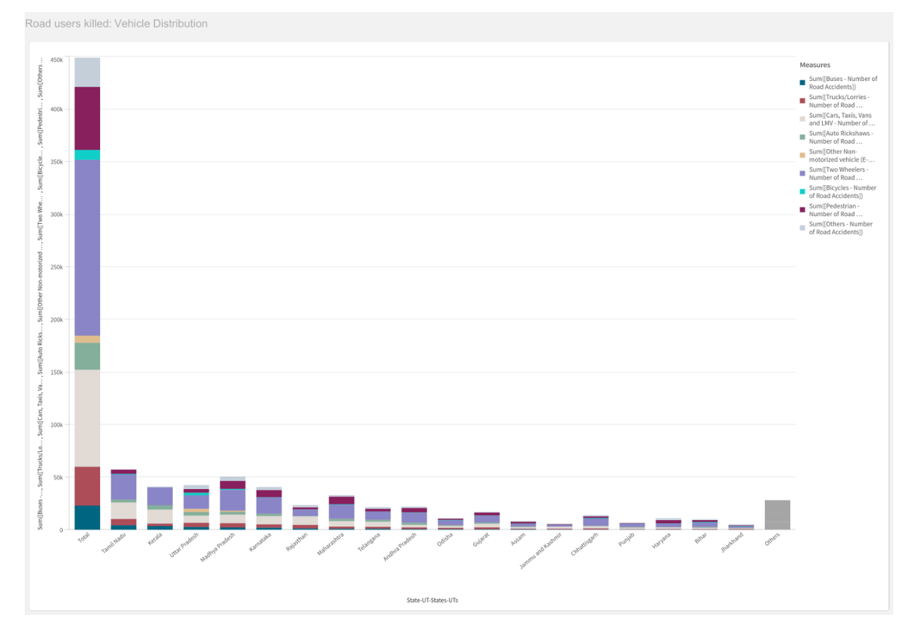

Activity 1.8: Correlation - Speeding and Number of accidents

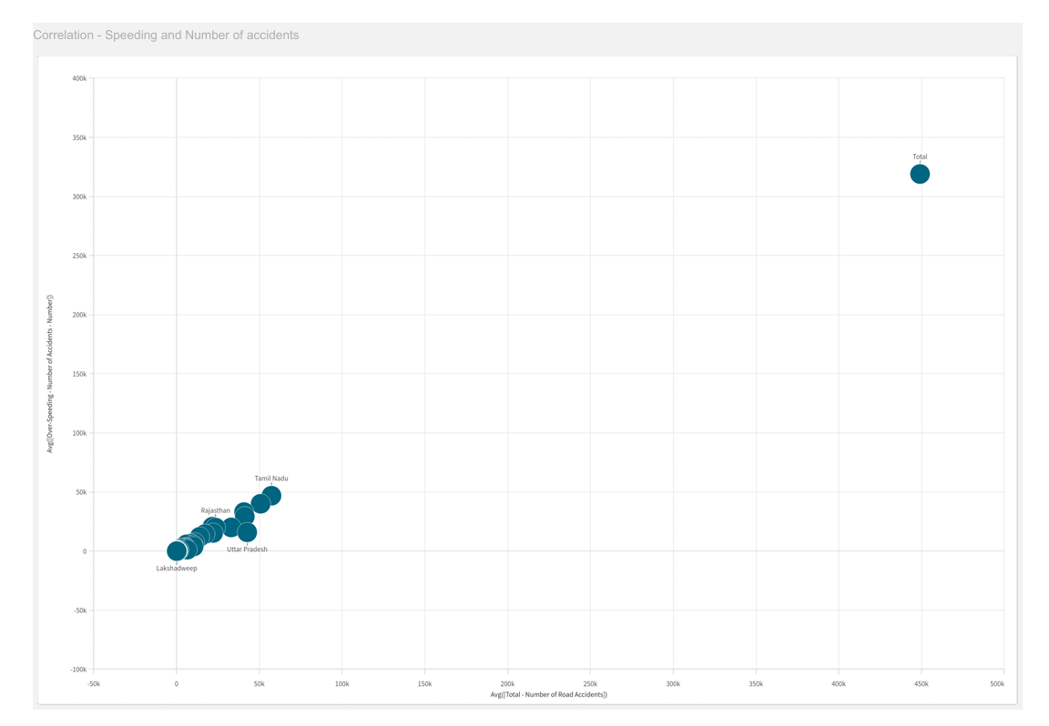

Activity 1.9: Minors Injured across the country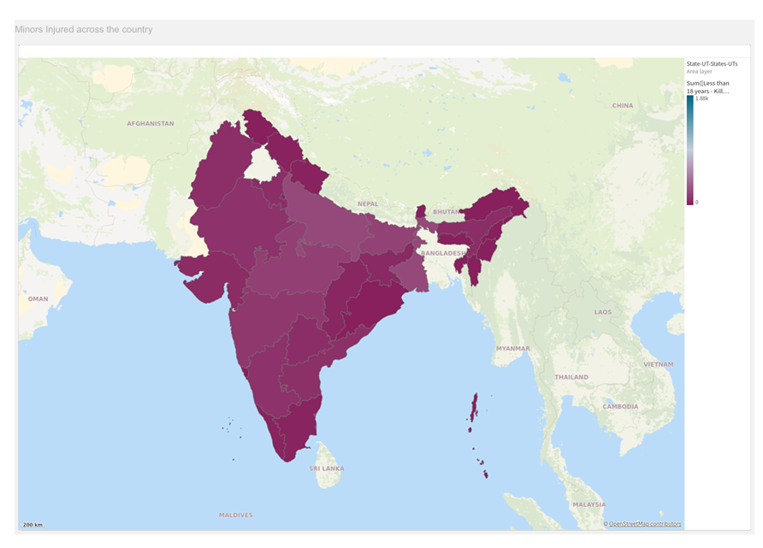

Activity 1.10: Accidents due to Flashing Signal/Blinker

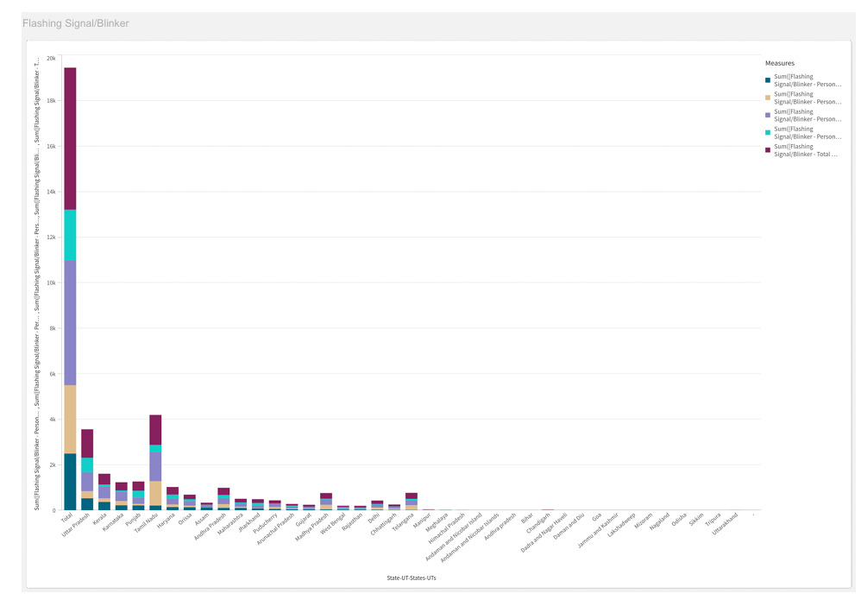

Activity 1.11: Accidents due to Stop Sign

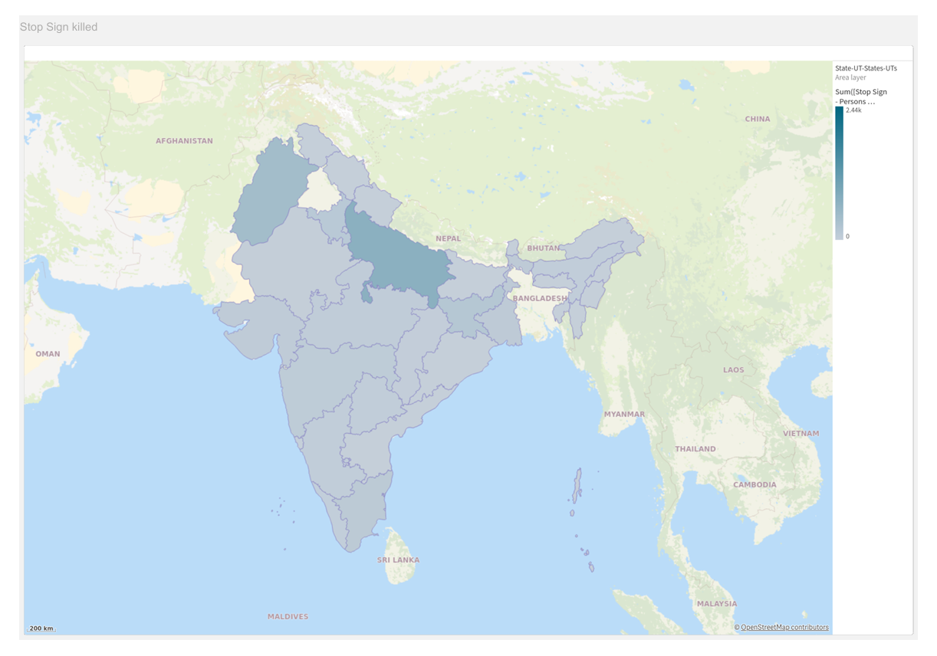

Activity 1.12: Police Controlled Accidents

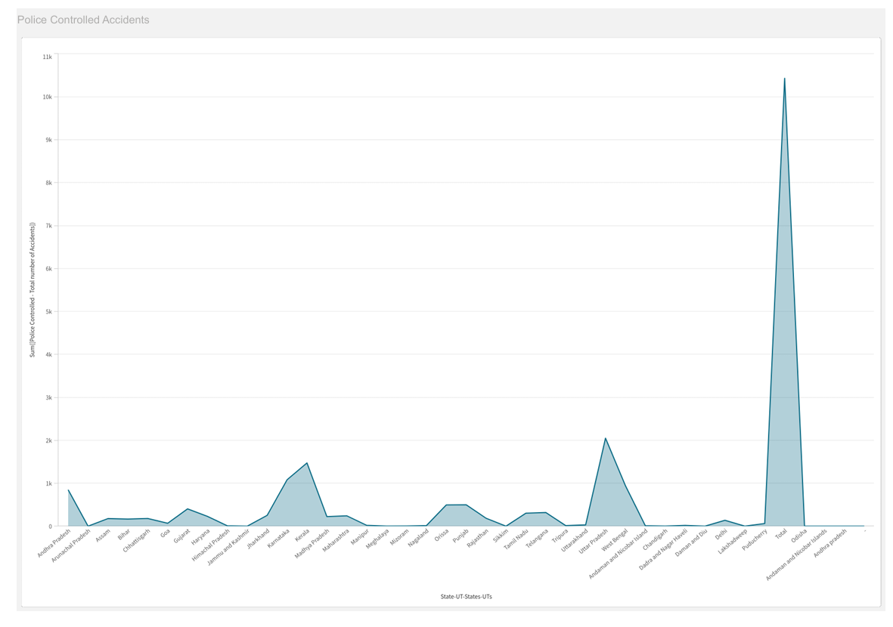

Activity 1.13: Accidents due to Hail/Sleet

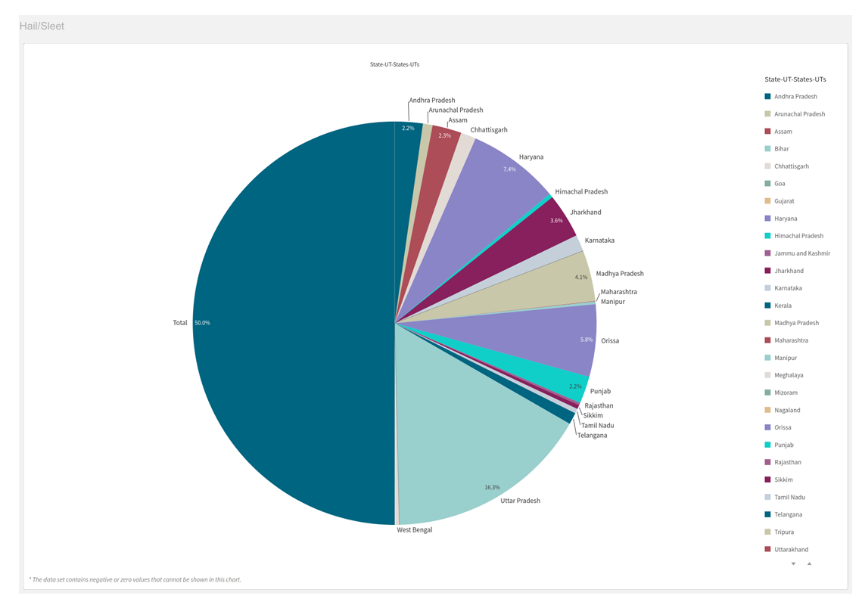

Activity 1.14: Person Injured due to Mobile Phone Usage

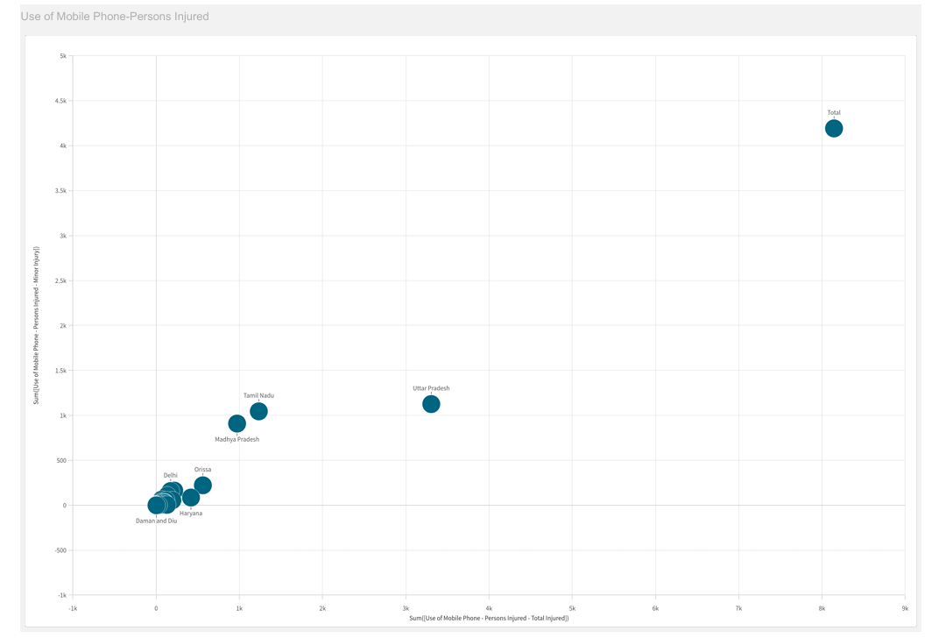

Activity 1.15: Person killed due to Bicycle

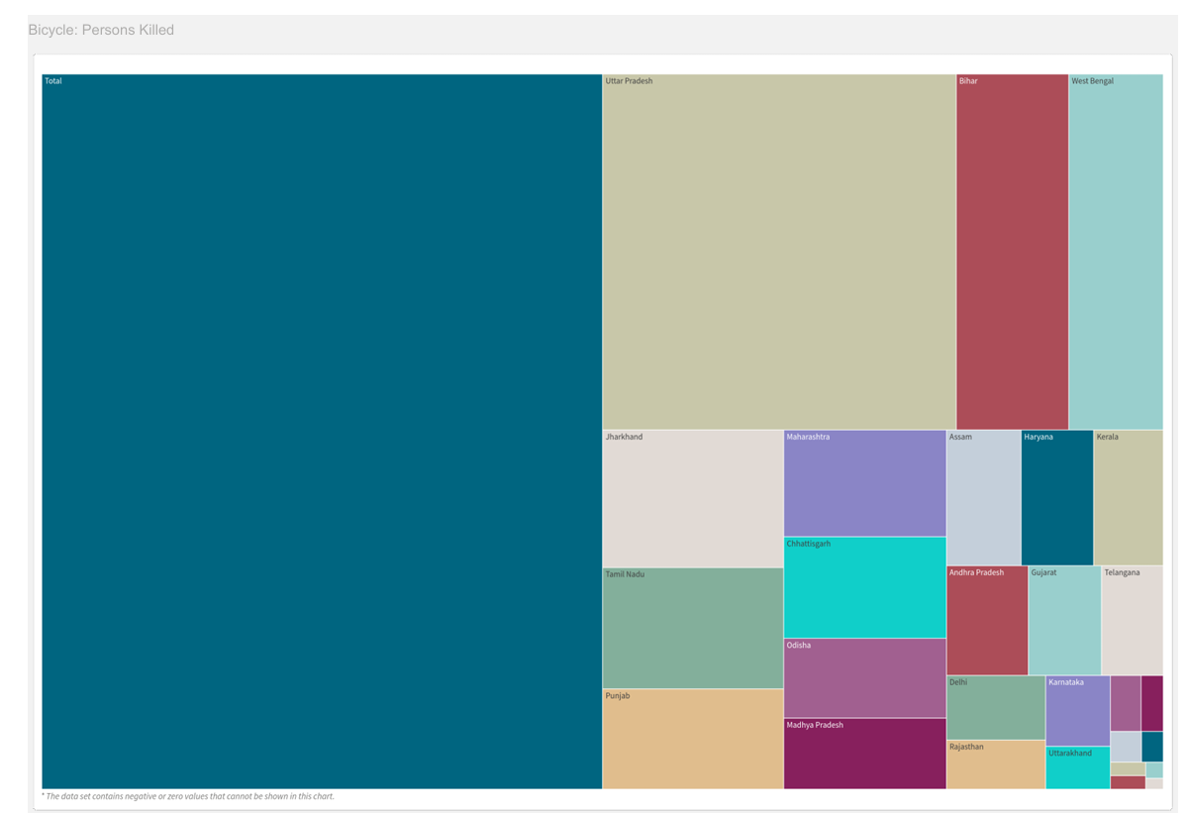

**Dashboard**

A dashboard is a graphical user interface (GUI) that displays information and data in an

organized and easy-to-read format. Dashboards are often used to provide real-time monitoring and analysis of data. They are typically designed for a specific purpose or use case. Dashboards can be used in a variety of settings, such as business, finance, manufacturing, healthcare, and many other industries. They can be used to track key performance indicators (KPIs), monitor performance metrics, and display data in the form of charts, graphs, and tables.

### Responsive And Design Of Dashboard

### 

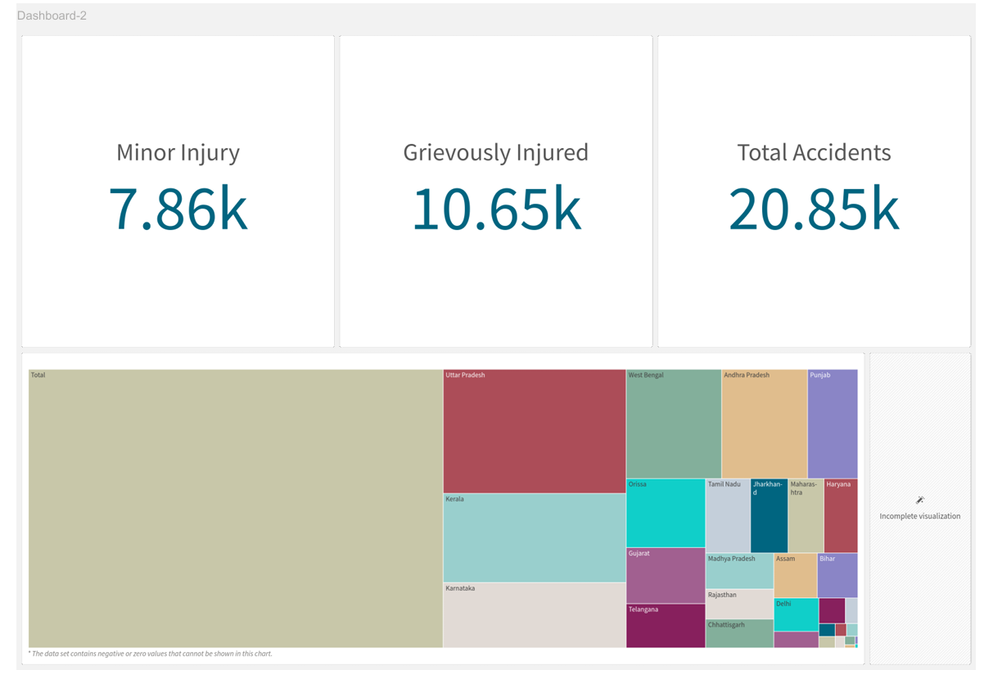

### Storytelling

A data story is a way of presenting data and analysis in a narrative format, with the goal of making information more engaging and easier to understand. A data story typically includes a clear introduction that sets the stage and explains the context for the data, a body that presents the data and analysis in a logical and systematic way and a conclusion that summarizes the key findings and highlights their implications. Data stories can be told using a variety of media, such as reports, presentations, interactive visualizations and videos.

### Design Of Story

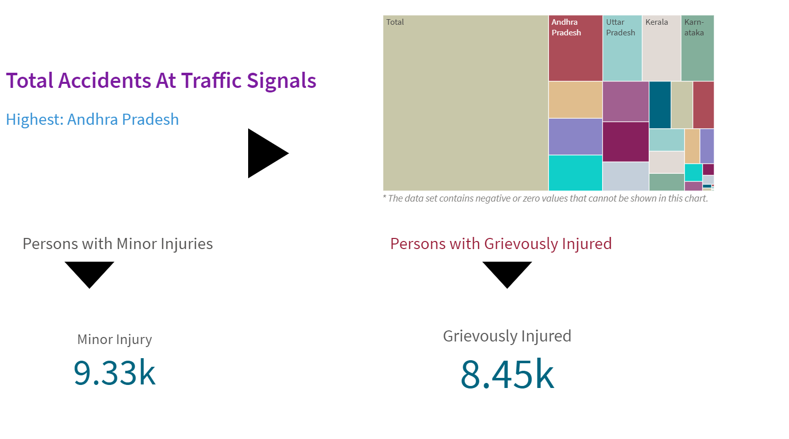

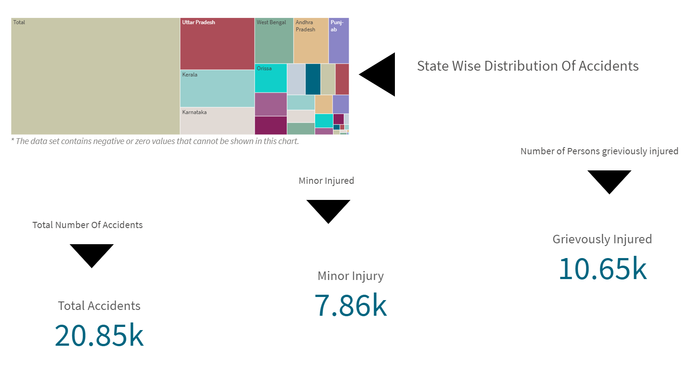

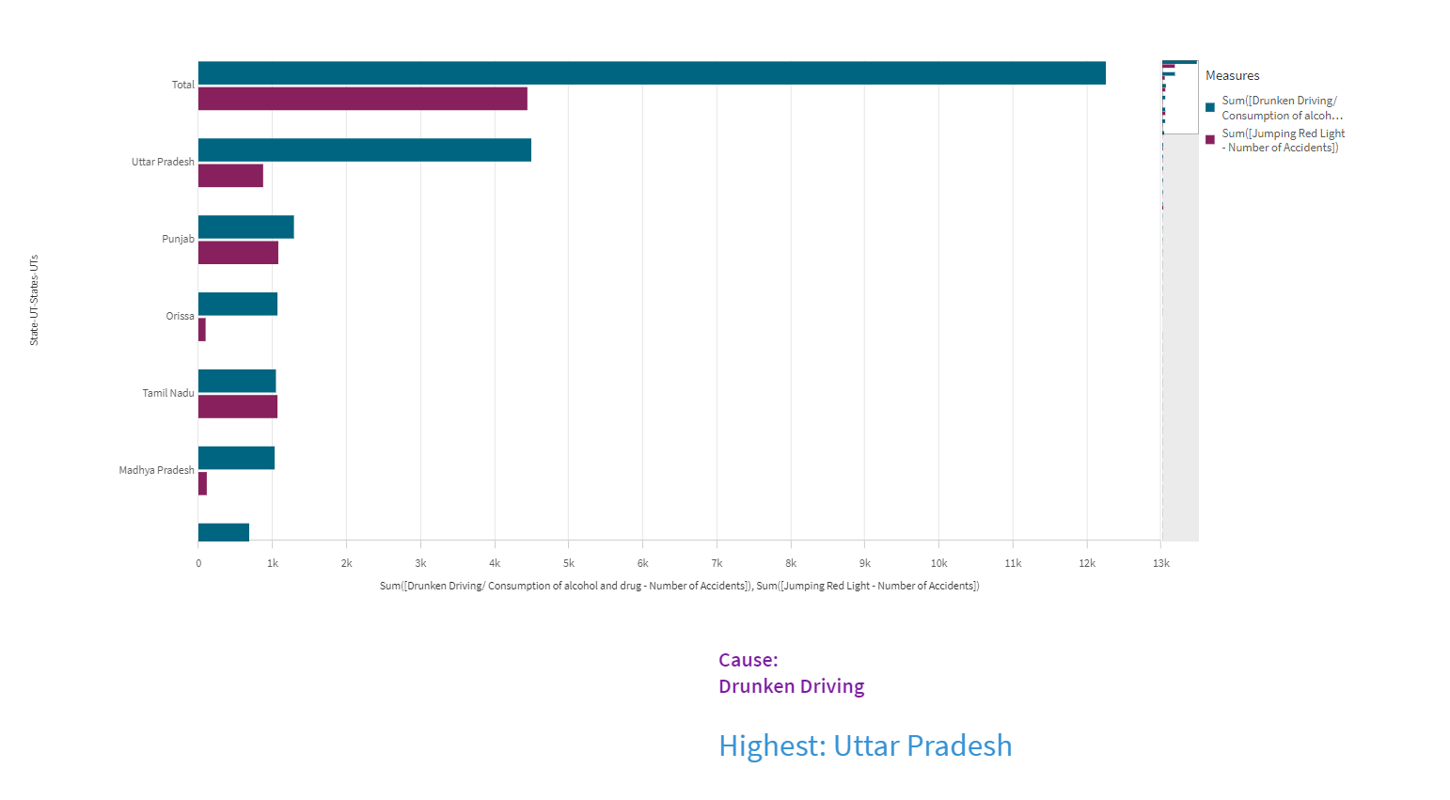

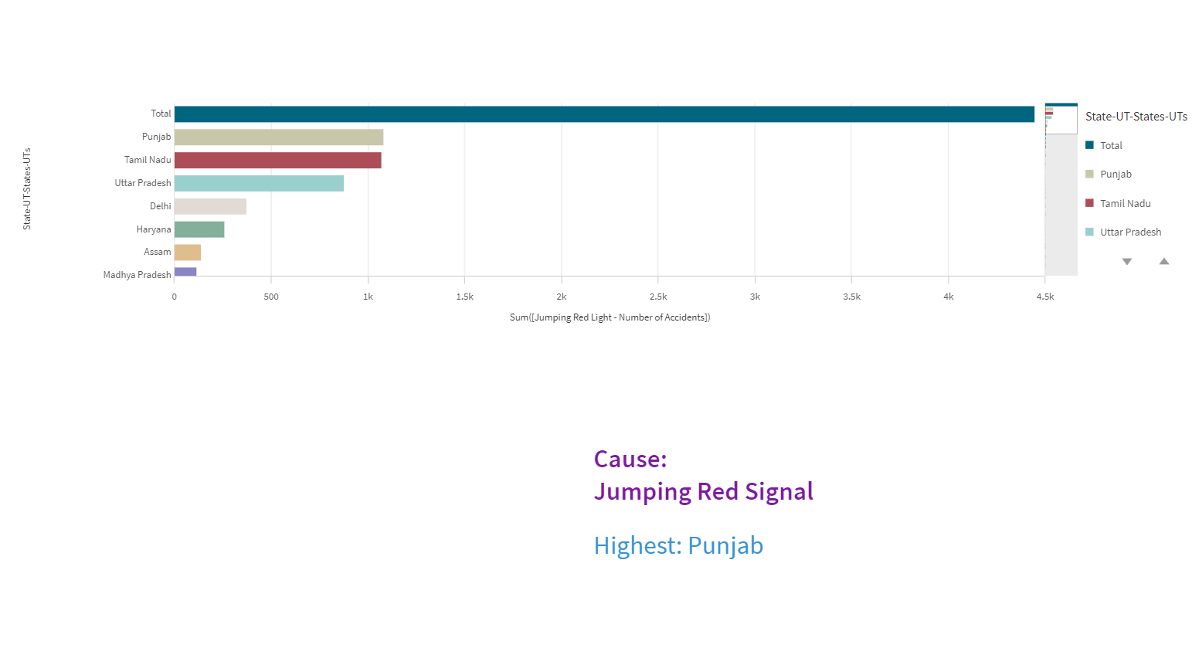

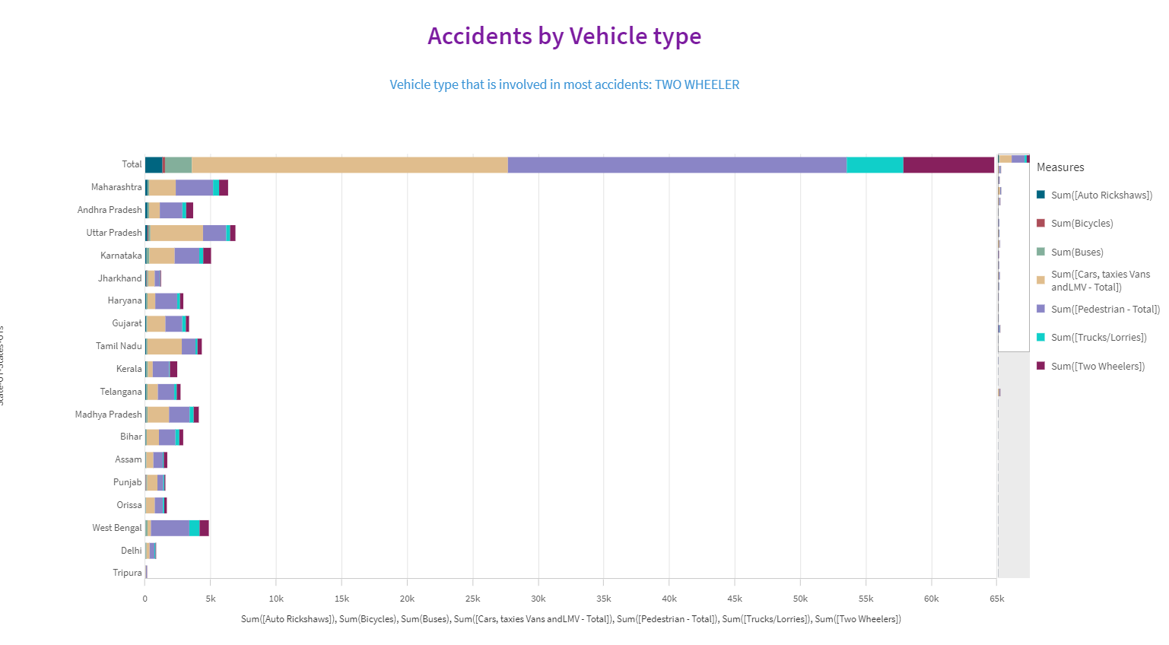

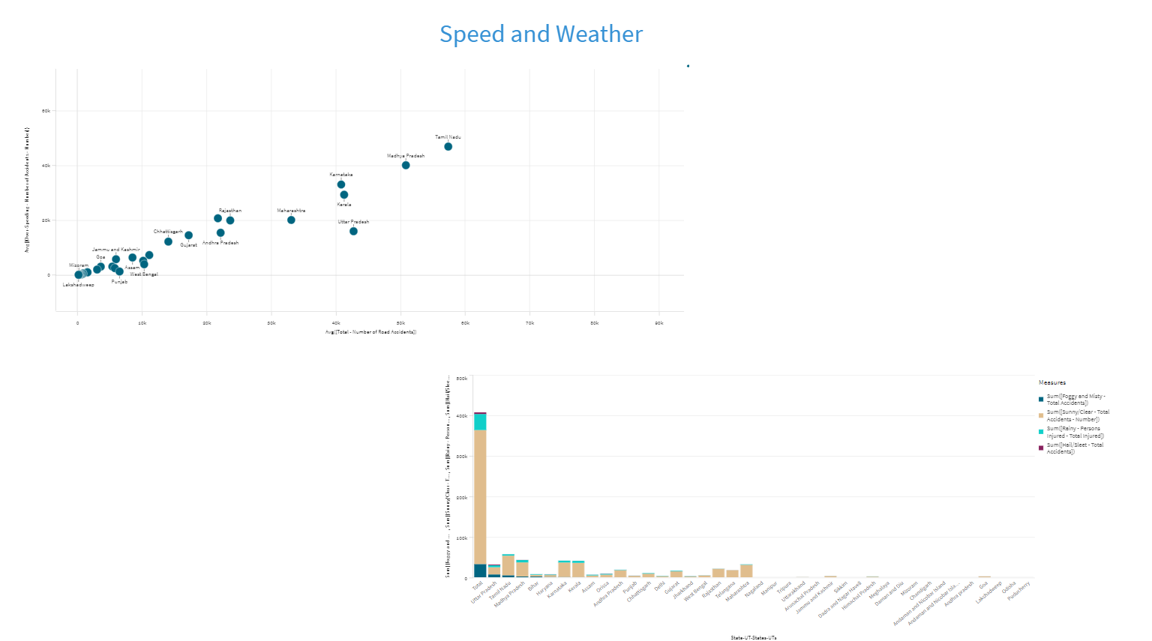

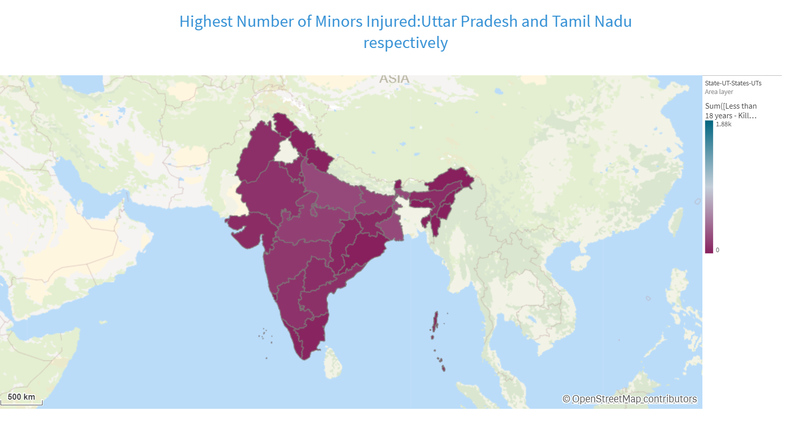

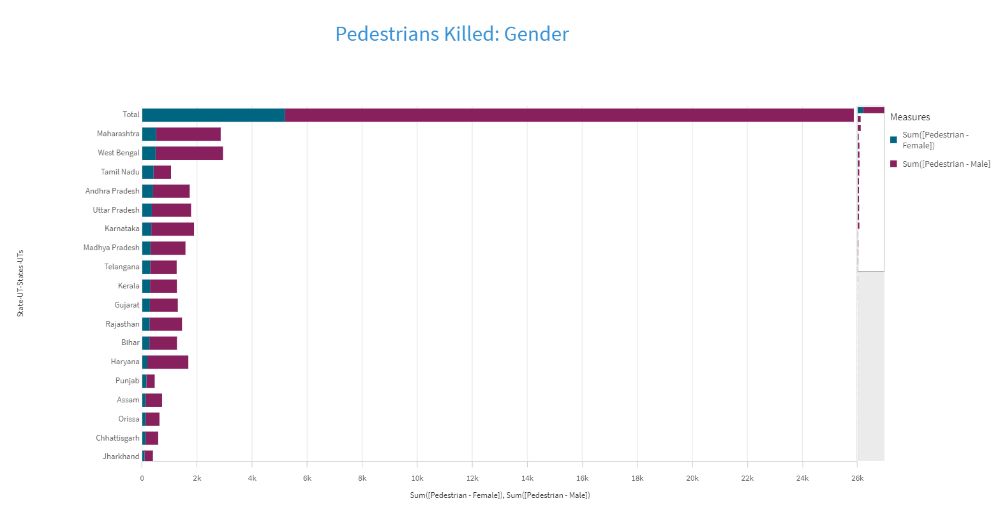

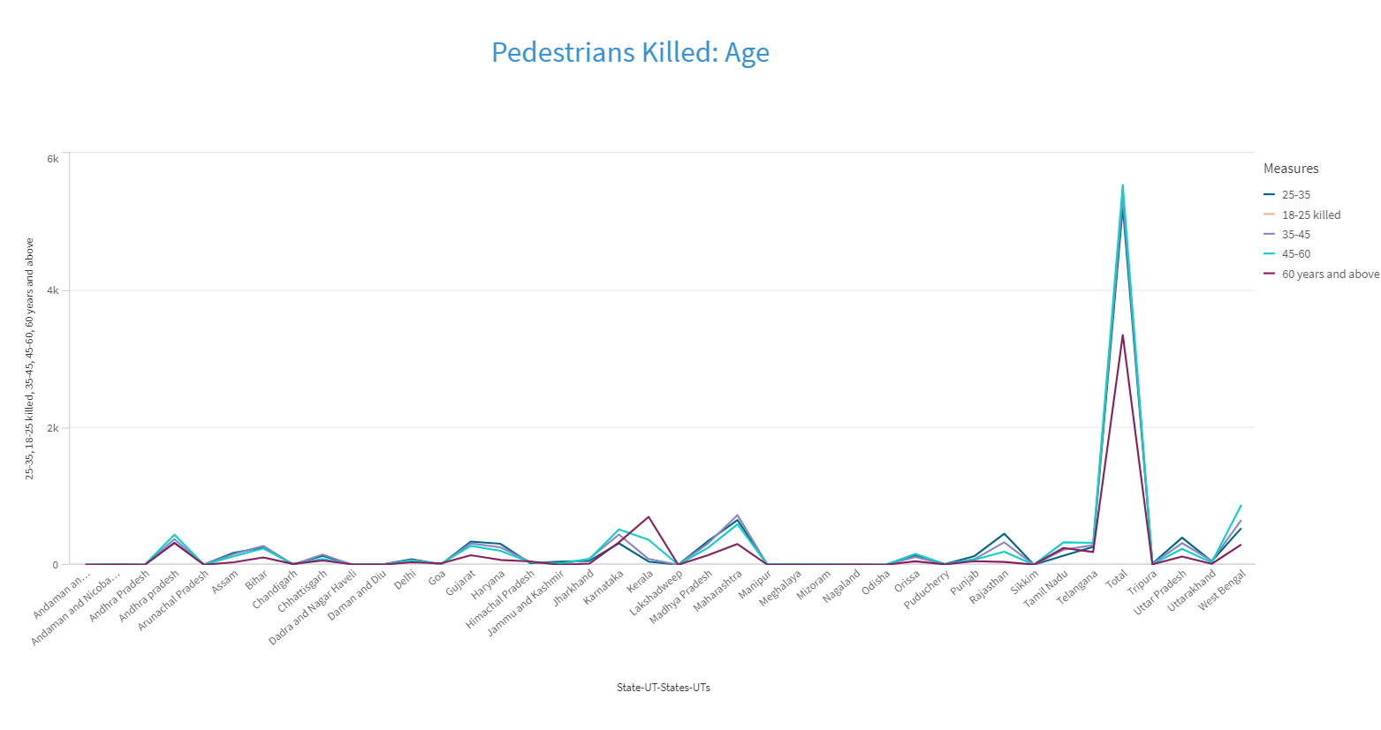

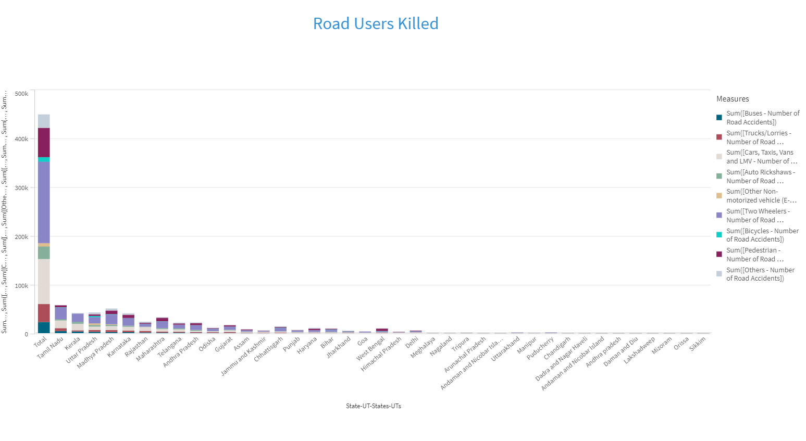

### Performance Testing

### Application Of Data Filters

Selections within the data allows users to filter data based on individual fields or dimensions. Users can choose specific values within a field to include or exclude from analysis. Complex filters based on predefined conditions and logic can also be created.

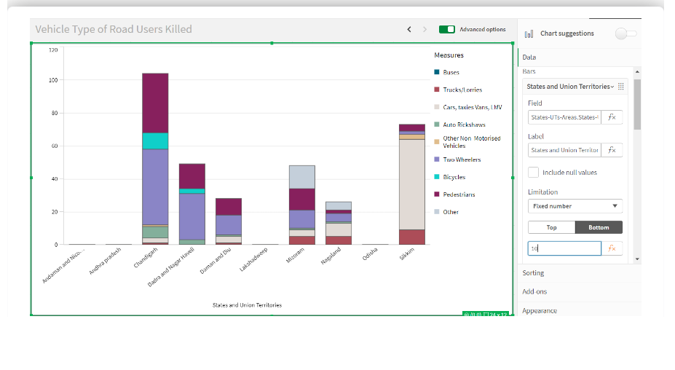

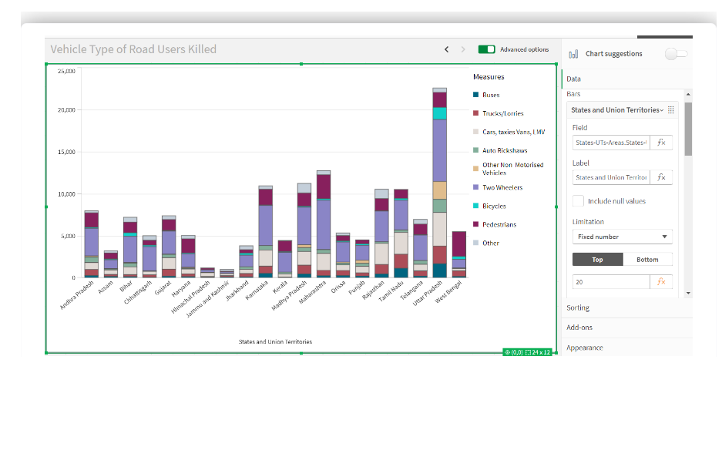

### Use Of Master Items/Calculated Fields

Qlik Sense allows the creation of reusable filter objects like Master Items, Calculated Fields which can simplify the process of applying consistent filters across multiple visualizations and dashboards.

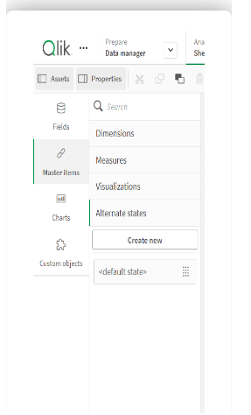

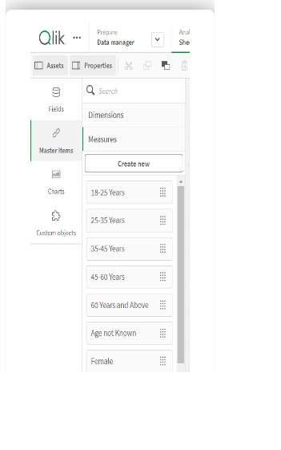

**Number Of Graphs/ Visualizations**

1. Accidents due to Drunken Driving
2. State-wise Mobile Phone Usage
3. Vehicle Contribution towards Total Accidents
4. Correlation - Speeding and Number of accidents
5. Accidents by Weather Type
6. Minors Injured across the country
7. Pedestrians Killed: Gender
8. Pedestrians Killed: Age groups
9. Road Users Killed: Vehicle Distribution

**Project Demonstration & Documentation**

Activity 1: Record explanation video for the project's end-to-end solution

Activity 2: Project Documentation-step by step project development procedure

Create the document as per the template provided.